Web page opening program
吴世博
- 运行展示
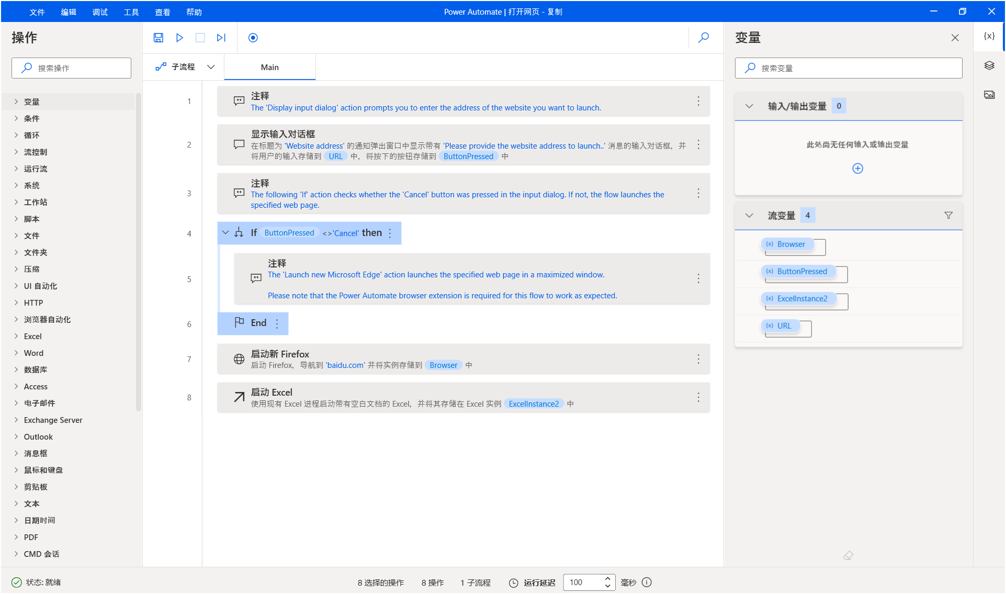
- 具体代码

# The 'Display input dialog' action prompts you to enter the address of the website you # The 'Display input dialog' action prompts you to enter the address of the website you want to launch.
Display.InputDialog Title: $'''Website address''' Message: $'''Please provide the website address to launch..''' DefaultValue: $'''flow.microsoft.com''' InputType: Display.InputType.SingleLine IsTopMost: True UserInput=> URL ButtonPressed=> ButtonPressed
# The following 'If' action checks whether the 'Cancel' button was pressed in the input dialog. If not, the flow launches the specified web page.
IF ButtonPressed <> $'''Cancel''' THEN
/# The 'Launch new Microsoft Edge' action launches the specified web page in a maximized window.

Please note that the Power Automate browser extension is required for this flow to work as expected.#/
END
WebAutomation.LaunchFirefox.LaunchFirefox Url: $'''baidu.com''' WindowState: WebAutomation.BrowserWindowState.Normal ClearCache: False ClearCookies: False WaitForPageToLoadTimeout: 60 Timeout: 60 BrowserInstance=> Browser
Excel.LaunchExcel.LaunchUnderExistingProcess Visible: True Instance=> ExcelInstance2

